Gravity & Orbits Worksheet

**Course:** “Defy”ning Gravity

**Materials:** Access to **PhET’s “Gravity and Orbits” Simulation**, a pencil, your imagination 🚀

**Created by:** Ryan Saelens

e1db5b30-42c5-474d-ad3b-534e5dc927ec.png

During this lesson, **you will be asked to do the following:**

* Run the simulation
* Complete activities
* Summarize findings
* Answer questions

Learning Goals:

* **Explore** and **understand** why objects in space **orbit each other**
* **Observe** how the **gravity** of an object **changes** **with a change in mass**
* **Investigate** how **distance** between objects **affects gravitational attraction**
* **Identify** **the relationship** between **gravity** and **orbital motion**
* **Model** how gravity acts as a **centripetal force** to keep **planets and moons in orbit**
* **Visualize** how mass and motion interact to **form stable orbits**

Quick Vocab:

**Gravity** - A **pulling force** between objects with mass

**Orbit** - The **path** one subject takes around another

**Planet** - A l**arge object** that **orbits a star** (like Earth or Mars)

**Star** - A big, **hot ball of glowing gas** (like our Sun)

**Velocity** - The **speed** of something **in a specific direction**

**Revolution** - **One full trip** an object makes **around** another (like Earth going around the Sun)

Now it’s time to strengthen your understanding of Gravity!

Module 1: Opening the Simulation

To **access/open** the **PhET simulation: Gravity and Orbits**, click [**HERE!**](https://phet.colorado.edu/sims/html/gravity-and-orbits/latest/gravity-and-orbits_all.html)

* Once the page opens, click, **“Model”** ⟶ **DO NOT** click, “To Scale”.

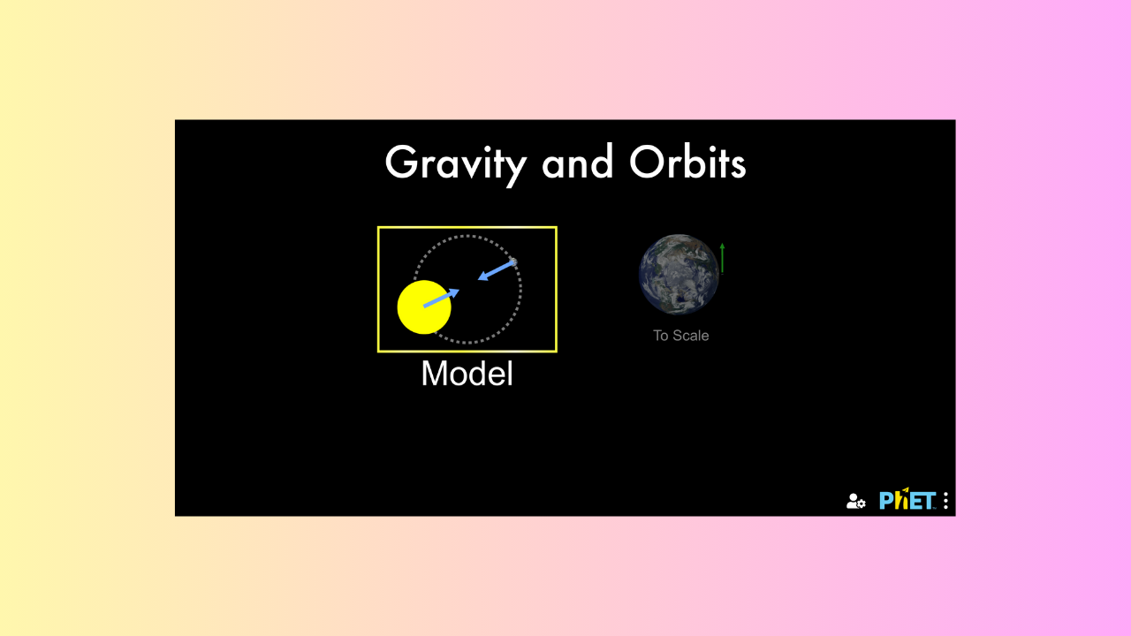

* In the middle of the screen, **you should see our Sun and** a small planet – our planet, **Earth!**

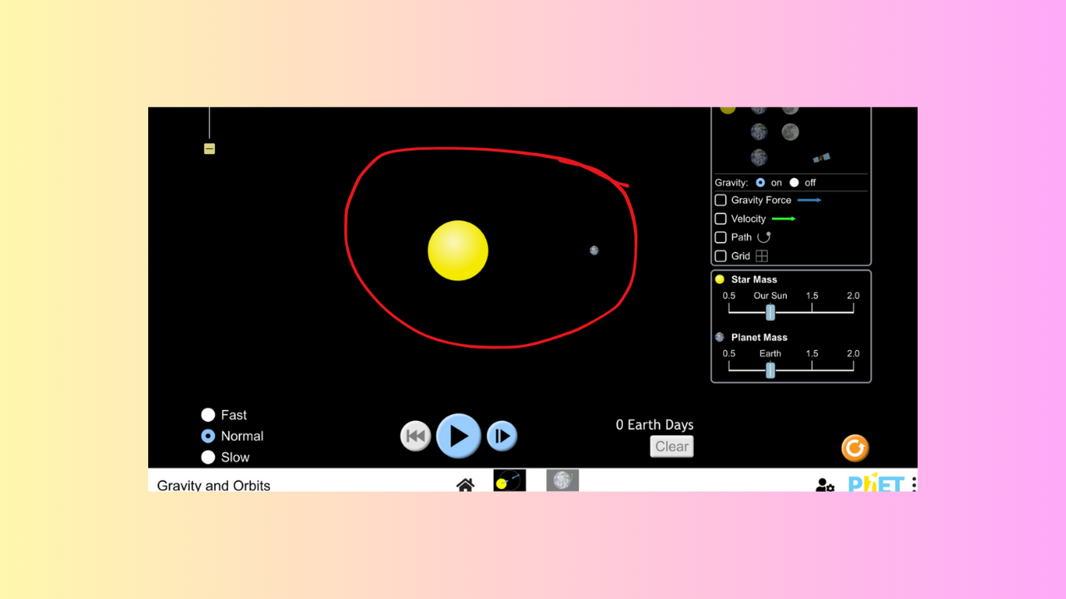

* **Continue** to the next module to **learn the layout** of the simulation!

Module 2: Learning the Layout

Take a few minutes to **learn about the different components of the simulation.**

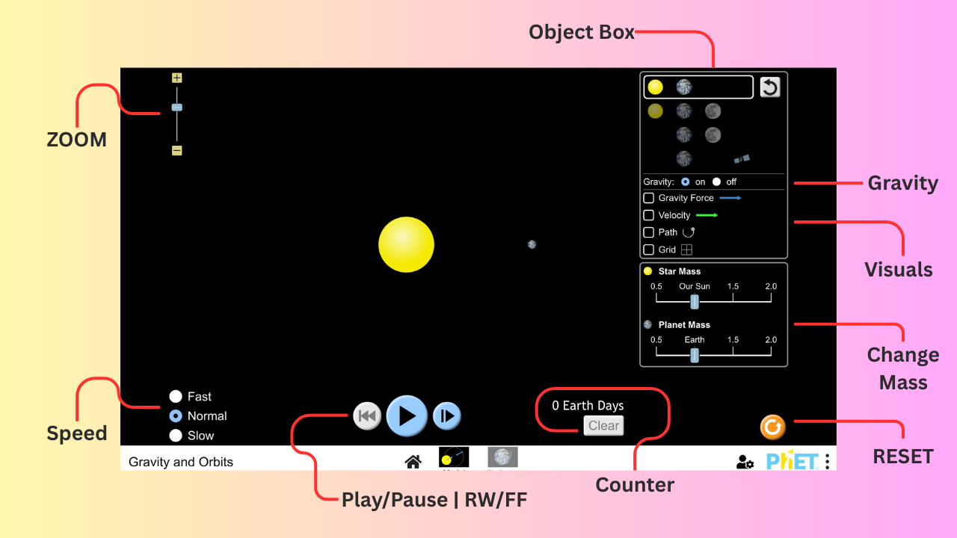

1. **Object Box** (Planets/Gravity/Visuals/Change Mass)
2. **Play/Pause, Rewind/Fast Forward**
3. **Counter**
4. **RESET Button**
5. **Zoom In/Zoom Out**
6. **Speed**

Module 3: Begin the Simulation

Start by exploring how **Earth orbits around our Sun!**

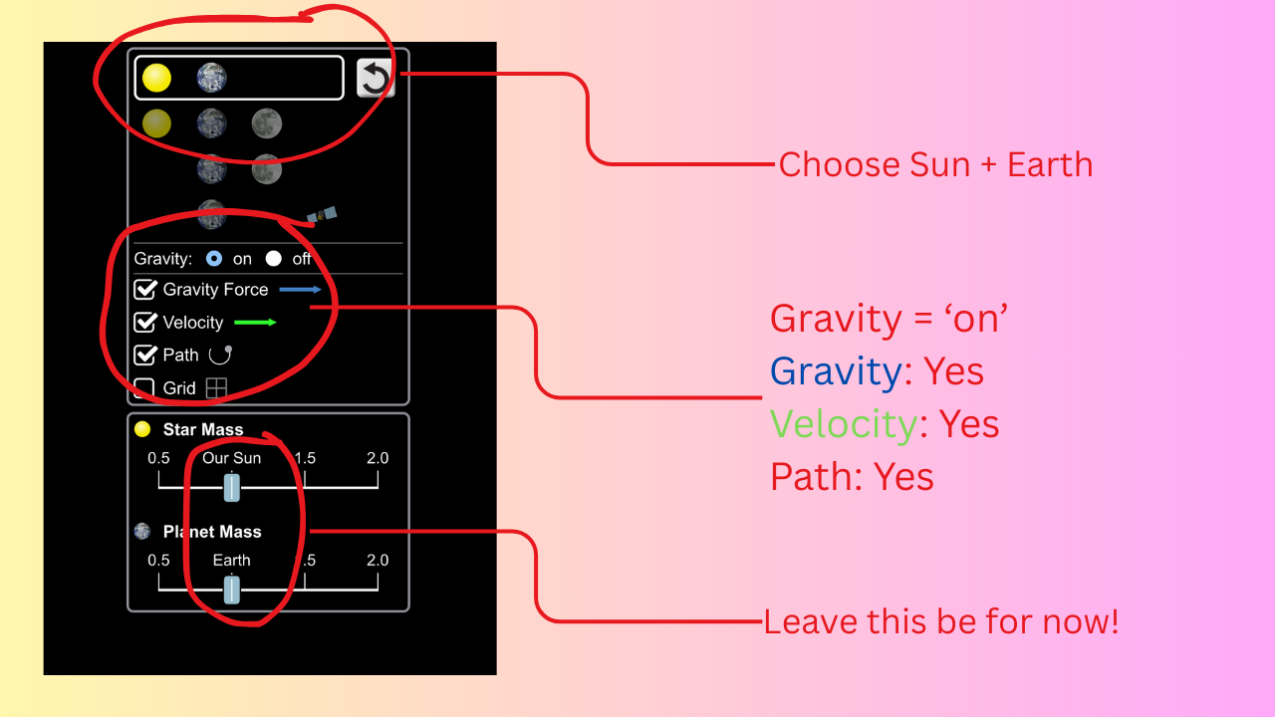

* In the **Control Panel**, choose the option that displays our Sun and Earth.
* **CHECK** the ‘Gravity’ & ‘Velocity’ boxes. **They can be turned off later**, but it’s nice to have them on to help build a strong understanding.
* Also make sure the **‘Path’ box is CHECKED!** WE WANT TO SEE THE ORBIT!
* DO NOT change anything else – **yet!**

Now it’s time to begin the simulation!

* With the chosen options from above, press the **PLAY BUTTON** to **start the simulation!** 
  + What do you notice about the **orbit of the planet?** 
    - What **shape** does it make?
  + **How long** does it take **Earth to complete an orbit** (one complete path) around our Sun?
  + What do you notice about the **blue arrows** (gravity)?
    - What about the **green arrow** (velocity)?

Module 4: Change Sun Mass (1.5)

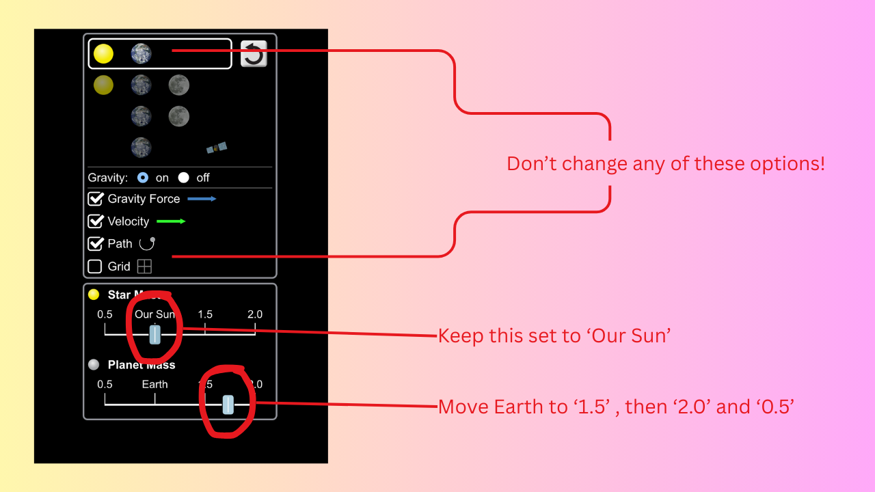

* First, hit the **RESET** button
  + Then, **move the Sun’s mass** to the right **until it reaches 1.5**
* **What happens to Earth’s orbit?** 
  + What **shape** does it make now? **Is it like the last orbit?**
* Does Earth get **faster or slower** as it gets closer to the Sun?
  + What’s going on with the **blue arrows** (the gravity arrows)?

Module 5: Change Sun Mass (2.0)

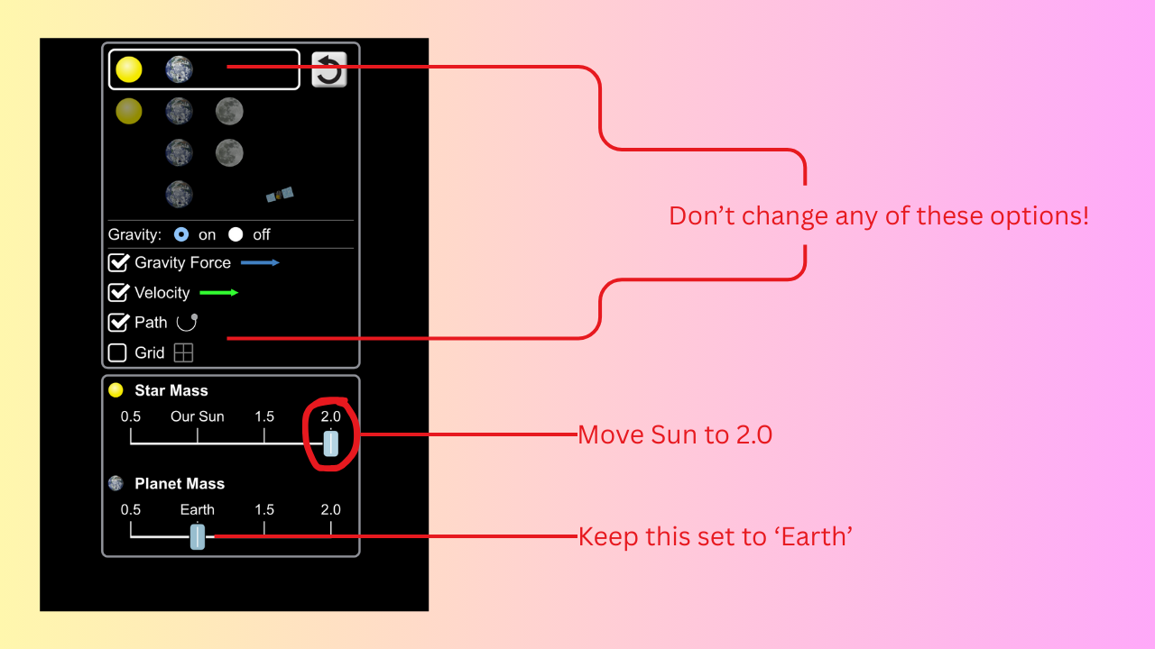

* Again, hit the **RESET** button **before changing the mass of the Sun**.
* **After** the mass of the **Sun has been set to 2.0**, **PRESS PLAY** and let it run for a moment.
* **What changes** do you notice now? Be sure to write them down. Remember, you can always **PAUSE** the simulation if you need time to write!
* Does Earth’s speed change?
  + If so, is it **faster or slower**, with the increase in the Sun’s mass?

Module 6: Change Sun Mass (0.5)

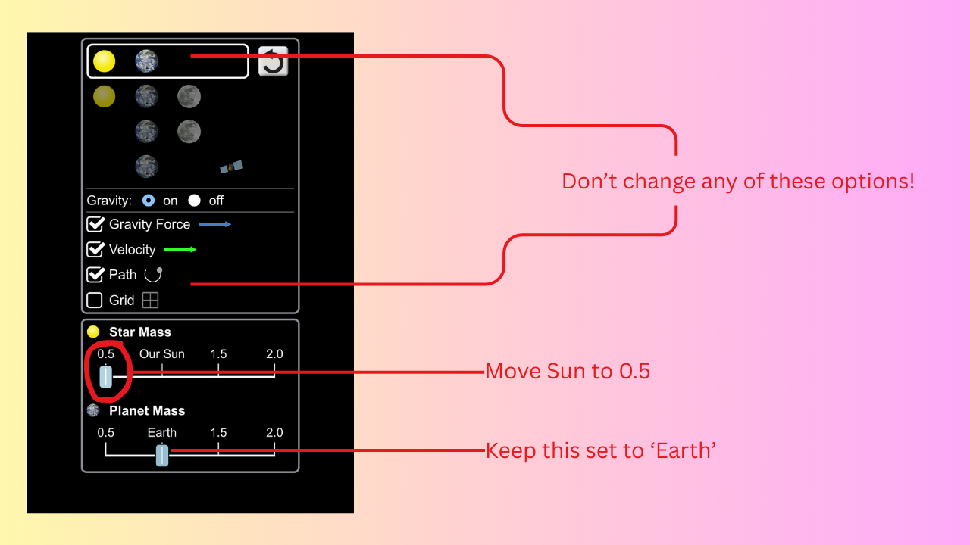

* Once again, hit the **RESET** button before **changing the mass of the Sun!**
* **After** the mass has been **set to 0.5**, **PLAY** the simulation.
* Does Earth **stay in orbit**, or does it **drift off into space?**
  + Remember that **orbits can be quite large**, so **ZOOM OUT** and **WAIT** a moment to see if Earth Returns.
    - If Earth does drift away, try to observe if it **has a curve to its path**, or if it **drifts away in more of a straight line.**
* **RESET** the simulation and **PRESS PLAY**.
  + **Now, slowly change the mass of the Sun,** **down to 0.5.** 
    - Observe and note any changes.

Module 7: Change Earth Mass



Now that you’ve successfully observed what happens when we manipulate the mass of the Sun, **we need to do the same for the Earth!**

* Take a second to **form a hypothesis** **(an educated guess)** of what will happen!
* After you’re done writing, and you have the **Earth’s mass set to 2.0,** **PRESS PLAY!**
* Does anything happen? **If so, what exactly?**
  + Is the gravity **stronger** between the two objects, or **weaker?**
  + Does the Earth get **faster or slower?**

Module 8: Fun Exercise of Your Choice!

By now, you’ve observed what happens when you **alter the mass of the Sun and the Earth.**

* Now, **choose** a pair of objects **from the Control Panel** (it could be Earth + Moon, or Earth + Satellite – whatever you want!).
* **Perform** the same tasks on both objects **just like you did above** with the Sun and the Earth.
  + **Change the mass** of **one object at a time**, at first.
    - Remember to **RESET** the simulation as needed.
  + Now **RUN** it again and **change the masses of both objects** **(keep the simulation running as you change them).**
* **RESET** the simulation and **UNCHECK ‘GRAVITY’** from the Control Panel
  + What happens when gravity **gets turned off?**

After playing around with the simulation for a bit, **please answer the questions below.** Be sure to **save your notes** and answers to **add to your portfolio!**

Module 9: Answer Questions

1. What is gravity? Please use your own words.
2. What happens if the force of gravity is weakened between the Sun and the Earth? (Think of other planets that are further away from the Sun than Earth is – do these *other planets* experience the same amount of gravitational force as the planets that are closer do?
3. How does gravity affect the orbit of a moon around a planet?
4. Why does Jupiter have more moons than Earth?
5. Did the Earth remain the same speed after increasing the size of the Sun?
6. What would happen to the Earth, if the Sun suddenly lost its gravity?
7. What would happen to us all on Earth, if the Sun suddenly lost its gravity?

Up Next: Lesson 3 – Dancing with the Stars and planets!